Ericsson BNSI Call Gapping alarms LLD
Version | Date | Author | Description
0.0 | 16th Nov 2011 | Chris Janes | Original

Description
This doc describes the updates to be made in the BNSI rules files for the Call Gapping alarms generated by BNSI nodes.

HLD:
When BNSI works at 100% of its capacity the alarm ‘Intp TlmProcGroup_513:Limit ID
01340G2081CccGL_GlobalLimit has reached 100% of effective limitation [Severity:
Major]’ appears. A TT should be raised for this alarm after 5 min.

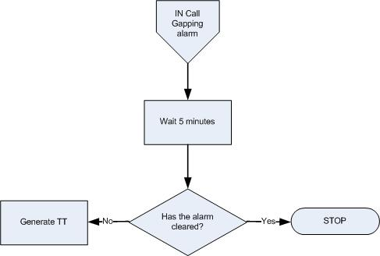

BNSI Call Gaping alarm handling Flow Chart

Pre-requisite
- Map added into TSRM between EventId “NET_IN_CGA_001” and classification “CALL GAPPING ALARM-IN”
- The TTHibernate field was added to the ObjectServer schema
- ML_RaiseTT_FirstOccurrence trigger was added in the ObjectServer

Event Filter:
Alarm description | Domain | Field | Value | EventId
BNSI Call Gaping alarm | BNSI | Summary | IntpTlmProcGroup_xyz:Limit ID xyz CccGL_GlobalLimit has reached 100 % of the effective limitation rate of xyz req./1000s..,  Matching condition:  regmatch(@Summary, ".* GlobalLimit has reached 100 \% of the effective limitation rate") | NET_IN_CGA_001

Logic:

BNSI Call Gaping alarm received
- Assign EventID and Domain for the relevant network alarms as defined in event filter section.
- Set TTHibernate field to 300 seconds

After TTHibernate time
- The ML_RaiseTT_FirstOccurrence trigger checks for TTHibernate>0, Severity>0 and CurrentTime-FirstOccurrence>=TTHibernate and sets the alarm for ticketing (@LogTicket=1).

Resolution of events
EventId | Resolution mechanism
NET_IN_CGA_001 | Clearance of the network event is managed by its resolution event.

